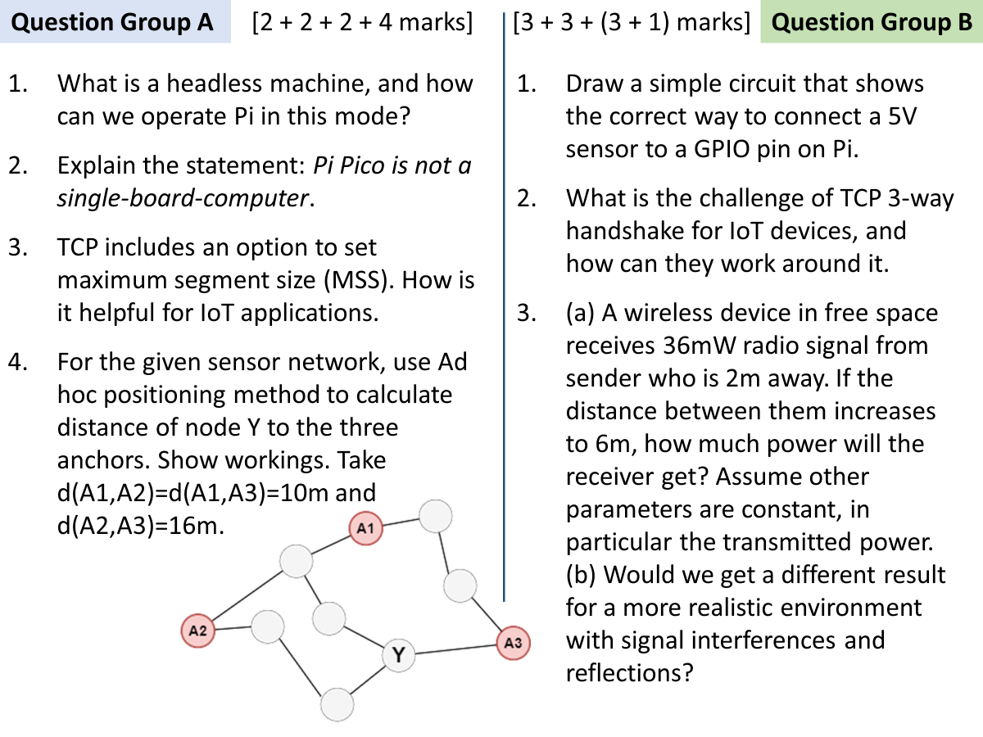

A

1

A machine operating without a display screen is called headless.

Pi can be setup can headless by installing remote login (ssh) or remote desktop (vnc) server software.

2

Pico contains a much weaker microcontroller with limited computation and memory – not enough to run an operating system.

3

1. Settings a small MSS can help in IoT because smaller segments imply less memory required at both sender and receiver.
2. Some IoT applications have a limited MTU at the link layer. (e.g. IEEE 802.15.4). For such cases, small MSS means packet fragmentation won’t be needed by layer 3.

4

c1 = $\frac{10+10}{2+3}$ = 4 c2 = $\frac{10+16}{2+4}$ = 4.33 c3 = $\frac{10+16}{3+4}$ = 3.7

Y will use correction factor of closest anchor (c3).

d(Y,A1) = 3.7 × 3 hops = 11.1

d(Y,A2) = 3.7 × 3

d(Y,A3) = 3.7 × 1

Marker’s note: Its also OK if students use c1 or c2 to calculate distances of Y.

B

1

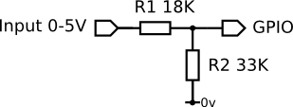

R1 and R2 should be chosen such that $\frac{R2}{R1+R2}×5$ roughly equals 3.3.

2

A new three-way handshake for connection setup can become a significant overhead for IoT nodes, e.g. a sensor sending periodic data might need to go through connection setup before every transmission

IoT devices can opt for long-lived TCP connections. If that is not possible, they may utilize TCP Fast Open feature in which the sensor node sends the data within the SYN packet.

3

(a) In free space $Pr ∝ {Pt}/{R^{2}}$, i.e. received power is inversely proportional to square of distance. In the given scenario, distance is increased 3 times (2m -> 6m), so the received power will be reduced 32 = 9 times. Hence new Pr = 36/9 = 4mW

ALTERNATE mathematical working:

Pr1 = 36, R1 = 2, R2 = 6

$$\frac{Pr1}{Pt}=\frac{G_{t}G_{r}λ^{2}}{{\left(4π\right)}^{2}{\left(R1\right)}^{2}}$$

$$\frac{Pr2}{Pt}=\frac{G_{t}G_{r}λ^{2}}{{\left(4π\right)}^{2}{\left(R2\right)}^{2}}$$

Divide 2nd equation by 1st,

$$\frac{Pr2}{Pr1}=\frac{{\left(R1\right)}^{2}}{{\left(R2\right)}^{2}}$$

$$Pr2=\frac{{\left(2\right)}^{2}}{{\left(6\right)}^{2}}36=4mW$$

(b) In realistic environment, the exponent of R increases from 2 to somewhere in 3-5 range.